Software requirement specification

for

online cab booking system

project:Go-safe

Prepared by:Koushik Andhavarapu

Organisation : Niit university

Date created :sept 18 2016

Table of Contents
Table of Contents
Revision History
1. Introduction
1.1 Purpose
1.2 Document Conventions
1.3 Intended Audience and Reading Suggestions
1.4 Product Scope
1.5 References
2. Overall Description
2.1 Product Perspective
2.2 Product Functions
2.3 User Classes and Characteristics
2.4 Operating Environment
2.5 Design and Implementation Constraints
2.6 User Documentation
3. External Interface Requirements
3.1 User Interfaces
3.2 Hardware Interfaces
3.3 Software Interfaces
3.4 Communications Interfaces
4. Domain Model
5. System Features (Use Cases)
5.1 Use Case 1
5.1.1 Name:
5.1.2 Goal:
5.1.3 Input:
5.1.4 Output:
5.1.5 Main Scenario:
5.1.6 Pre-condition:
5.1.7 Steps:
5.1.8 Post-condition
5.1.9 Exceptional Scenario 1
5.1.10 Example
5.2 Use Case 2 (and so on)
6. Other Nonfunctional Requirements
6.1 Performance Requirements
6.2 Safety Requirements
6.3 Security Requirements
6.4 Software Quality Attributes
7. Other Requirements
Appendix A: Glossary
Appendix B: Analysis Models
Appendix C: To Be Determined List

Revision History
Name | Date | Reason For Changes | Version

1.INTRODUCTION:

1.1 PURPOSE:

This SRS document is prepared to understand the concept of our project that is online cab booking system.The main goal of the system is that to improve the efficiency of our system than other online cab systems.The document gives you clarity about the system and the core feautures in it.It also explains the purpose and validity of the system.The online cab booking portal name is “Go-Safe”.This website is used to book cab directly through online.
So,we are creating version 1.0 and it will be developed further if there is a need to make any changes.The entire system is composed of two components i.e the software interface and the hardware interface.

1.2 DOCUMENT CONVENTIONS:

1.3 INTENDED READERS:

This is a project by the student of Niit university.This srs document is also a reading purpose for other developers if any other wants to develop our website.The document consists of the table of contents in the first page so the reader can follow accordingly.Also if anyone wants to build a website like ours they can use the UI design etc.. but not other contents.

1.4 PRODUCT SCOPE:

The product is used in real life purpose and the main aim of the product is that customer satisfation which can be achieved only if we create a well maintained smooth website.This product also deals with the interaction between the outside cab drivers to the website.The product is used mainly by students and it will be further available to other
citizens.

1.5 REFERENCES:

The format of this document is taken from combinations of other documents.All those documents are taken directly from internet and other sources of this document is available on google images.We had also went through some of the pdf’s and ppt’s that are available on internet.

2.OVERALL DESCRIPTION:

2.1 PRODUCT PERSPECTIVE:

This product that we have designed is follow-on member of a product family.since there are
many online websites for cab booking system and this is also same as them.This is mainly the students who have had faced difficulty when leaving from their university.We are also making this website in such a way that it is capable of sharing feature in it.This also improves the customer satisfaction.The user have to login and when booking a cab he can view the no of seats in the respective car and then he can also check the availability of the cabs.On the server side we will keep an employee/couple of them who connects between the cab drivers and customers.

2.2 PRODUCT FUNCTIONS:

The user have to sign-up if he is a new user and the existing user can directly use the product.It has also cab sharing feature between the customers.The user once done booking if refuses to use the product he have to contact directly to customer care.From the website itself he directly can view the no of seats and cabs available then he can book for the respective date.

2.3 USER CLASS AND CHARACTERISTICS:

The user should have a knowledge about internet and he should use a online booking system before so that it becomes handy to him.Default browser language is english so,he should also know english
User classes:
Some of the user classes that is included in use case diagrams are
1.customer
2.employees
3.administrator

2.4 OPERATING ENVIRONMENT:

Any opearting system is used to use the product and the product is developed also on any operating system.The software used for database of the customer are phpmyadmin,mysql,000webhost.com.The user can open this website on any computer/laptop/phone according to his comfort.

2.5 DESIGN AND IMPLEMENTATION CONSTRAINTS:
This system does require timing as for sharing a cab the timing and date should be same for booking. We are using the database over a single company as for initial starting. Here we have made an easy to use interface which does not require any much experience for the client. Used language English. We are making this on WAMP server over initial or 000webhosting.

2.6 USER DOCUMENTATION:

There will be service for the clients who contact us,the contact number is provided on the website itself.Whenever the cleints feel any problem with driver the customer can give a message or phone to our customer care.

2.7 ASSUMPTIONS AND DEPENDENCIES:

The following are some assum and dependencies:

1.There should be proper internet connection and no customer is in a situation that he does not know how to use a proper internet and website.
2.Any third party software can easily affects the content of our website so we will make a website which help that website work effectively.We also make sure that the html content of our website is not that easily avaible to all other peoples.
3.The website works under database server so,we make sure that server wont crash and if the database is crashed there is no way we can get the customer details and our website may go into trouble.
3. EXTERNAL INTERFACE REQUIREMENT:
3.1 USER INTERFACE:
The user interface is done through some of web development programming languages like html,bootstrap,css software.The first page of the website contains a login button and user should register inorder to book a cab or to view their history.The website looks good from outside which makes the users satifiable.The unregistered has no access of information for the data of registered users.
3.2 HARDWARE INTERFACE:
1.Server side software:
Hardware recommended by the software needed.
Communication needed between client and server.
An employee who will work for us.
2. Client side hardware:
Hardware for clients is the operating system and web browser.
Communication knowledge for using the hardware to communicate with the server
3.3 SOFTWARE INTERFACE:
Server side software:
Web server we are thinking to use: WAMP server, 000webhosting.com
Scripting tool for coding: PHP, Sublime text editor,notepad++
Database tool for getting customer details: HIDE SQL,phpMyadmin
Operating system used server side: Windows,Ubuntu
Client side software:
Web browser used client side: ANY
Operating System used client side: ANY
3.4 COMMUNICATION PROTOCOL:
The server and client communicates through our website.since “Go-safe” is a small organization so in case on any help needed the customer can directly contact us.The communication can happen in both ways.

4.SYSTEM FEATURES:
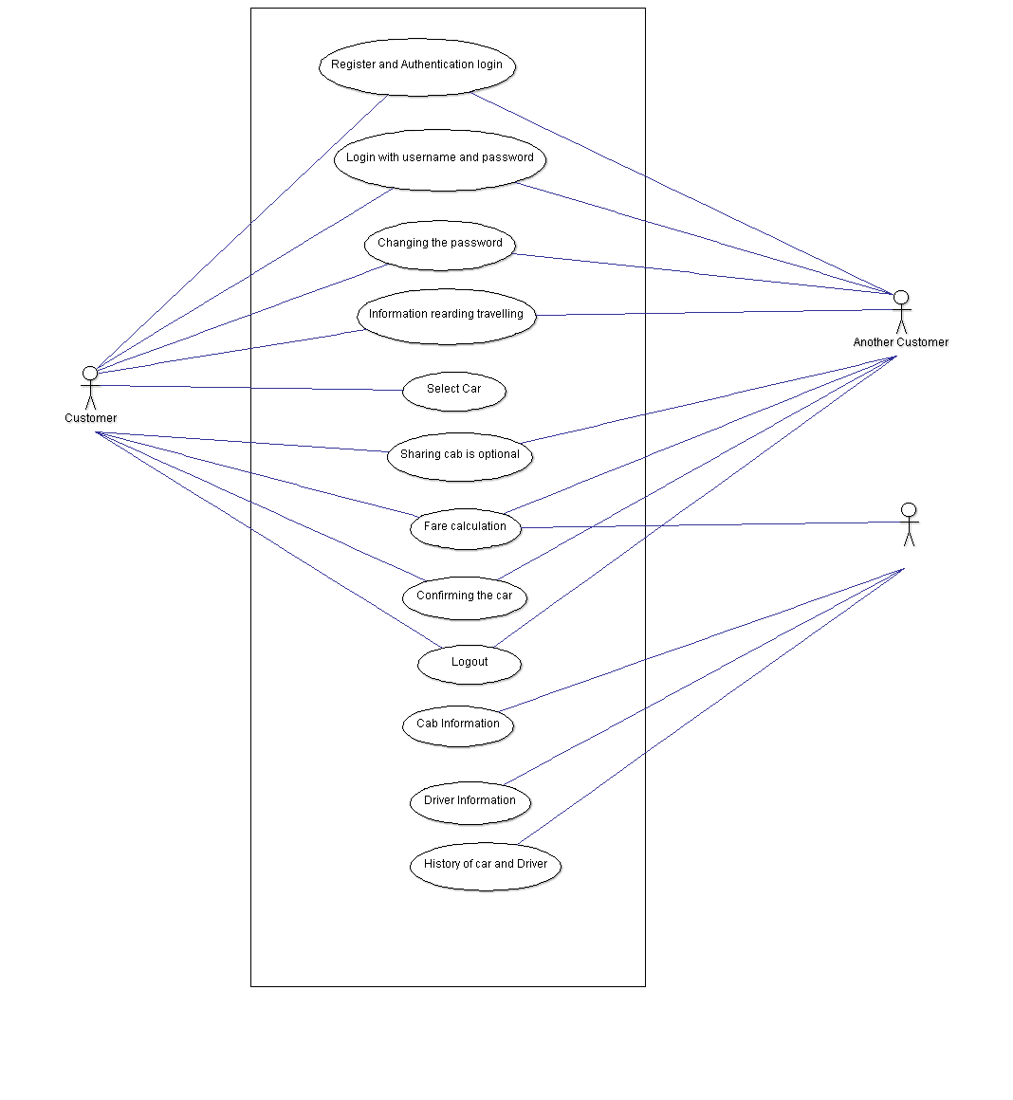
Requirement id Function
R1 Register and Aunthecation login
R2 Login with username and password
R3 Changing the password
R4 information regarding travelling
R5 Selecting cab
R6 Sharing cab is optional
R7 Fare calculation
R8 Conforming the cab
R9 Driver and the customer information
4.1 ADMINISTRATOR:
4.1.1 DESCRIPTION AND PRIORITY:
The administrator donot have the access to the customes details and he only uploads or maintain the website from running in the background.He supervisies the actions of the website from background.
1.1.2 Stimulus/response sequences:
The administrator will be provided a secure login like the customers but his type of dash board is different from other users.He will be inspecting the work of the customers.
1.1.3 functional requirements:
His dashboard consists of links from where he can operate.He also can cut off some clients who are not using the product safely directly from his account.Key password is only available with the administrator and not shared with anyone.
Requirements for the adiministrator:
Req 1-performly weekly roster of employees.
Req 2-print reports weekly,anually,daily.
Req 3-Check feedbacks.
Req 4-Send newsletters.
Req 5-Chlanging the super password that is available for the administrators.
4.2 MAILING:
4.2.1 Description and priority:
Mailing system is the one of important requirements for the software we are developing.An automated mail is generated and sent to the administrator and the client with the information of booking.
4.2.2 Stimulus/response sequences:
1.Mail will be sent to the user after successful booking of a cab
2.Mail will be sent to the administrator after the user gives a feedback
3.Mail will be sent to customer1 if the customer2 wants to share the cab with him.
4.A conformation mail will be sent to the customer2 after customer1 accepts sharing the cab.
5.A mail will be sent to the user if he forgot the password or username.
4.2.3 Functional Requirements
Automatic mail generator is developed using PHP .An automatic mailing system will generate all the necessary mails that are required with the use of PHP on the click of a button specified by developers.

Req1-Temporary password will be mailed to the user incase the user forgets the password.

Req 2- Newsletters should go the clients email addresses.

Req 3- The client should get notification email of the booking while confirmed.

Req 4- Admin will get a mail if any customer gives the feedback.

Req 5-Notification mail will be sent to the customer after getting any sharing request from any other customer.
4.3 CLIENT:
4.3.1 DESCRIPTION AND PRIORITY:
Here’s how the customer will login and logout from our system.What are the features clients can get experience from the system.
4.3.2 Simulus and response sequences:
1.Customer has to register otherwise he can’t access the features of the website.
2.After that the user has to login into our website with the particular username and password.
3.Then the customer has to give the date, time, and location for the cab to arrive.
4.Then select the cab from the available list of cabs from our website.
5.The client can cancel the cab in a span of hour in some cases.
6.The client can even go for sharing the cab if the client want.
7.After booking the MAIL will be sent.
8.Then the client can logout from it.
4.3.3 Functional requirements:
The customer has to register himself and then only he can able to view the content.There will be the aunthecation for the client,wethere the user is giving the correct details or not.After logging in the customer can book a cab and he/she can also cancel within span of time.The details of the cab driver will be sent to the cab driver and the customer both.
1.Req 1: Register and Login in our website
2.Req 2: Authentication of the login
3.Req 3 : Logout from the website
4.Req 4 : Change Password
5.Req 5 : Resetting the password
6.Req 6 : Date, time and location
7.Req 7 : Selecting cab
8.Req 8 : Cab booking

5.OTHER NON-FUNCTIONAL REQUIREMENTS:
5.1 PERFORMANCE REQUIREMENTS:
We make the website look good and will change the content in it from time to time.The website is also eco-friendly and we guarantee that it will be in a proper condition i.e is in full condition.We also develop the website from time to time.The database that is used to store the users information is also stored in a proper way such that data is easily retrieved.there are two major performance we have to concentrate on.

5.2 SAFETY REQUIREMENTS:

We are making a sample website and that is created using webhosting servers online.Rightnow it is temporary and after we make chnges.The changes we mean is that the website receives some certifications and then it is used for outside world.

5.3 SECURITY REQUIREMENTS:

The client has to register himself with a username and password.The client logins from with that information. This way the profile and history of travels done by the client is safe with him and no longer other users can have access.We also make sure that the cabs associated to customers are in a good condition and these are no longer a fake one or the driver is making mistakes.

5.4 SOFTWARE QUALITY ATTRIBUTES:

Any developer can view our content that is by which we have made the website.our website serves the customer best and feedback is taken from different customers.So in that way we can improve the website effeciency and project aim.Our website is eco-friendly and it should also support latest technology tools also.The speed of the work is main concept in our website like this.

5.6 BUSINESS RULES:
If we get any negative feedback from the clients then we may cutout the agreement from the small companies as this is leading to clients unhappy.The role of company is to always updating the status of cab.A employee is kept to check the status of the cabs and he will directly upload the status to the website.The employee will be under our survillance,the group of founders.

6. OTHER REQUIREMENTS:

We are making sample website for the company as of now but the main task will be when it goes international.Then we have to manage databases of lots of people and fight aganist any hackers if so.We also rely on the objectives of other cab booking like uber,Ola and cabahead for cab sharing.We will slowly implement things of our website.
APPENNDIX A: GLOSSARY
HTML:Hyper text markup language
SQL:Structured query language
CSS:Cascading style sheets

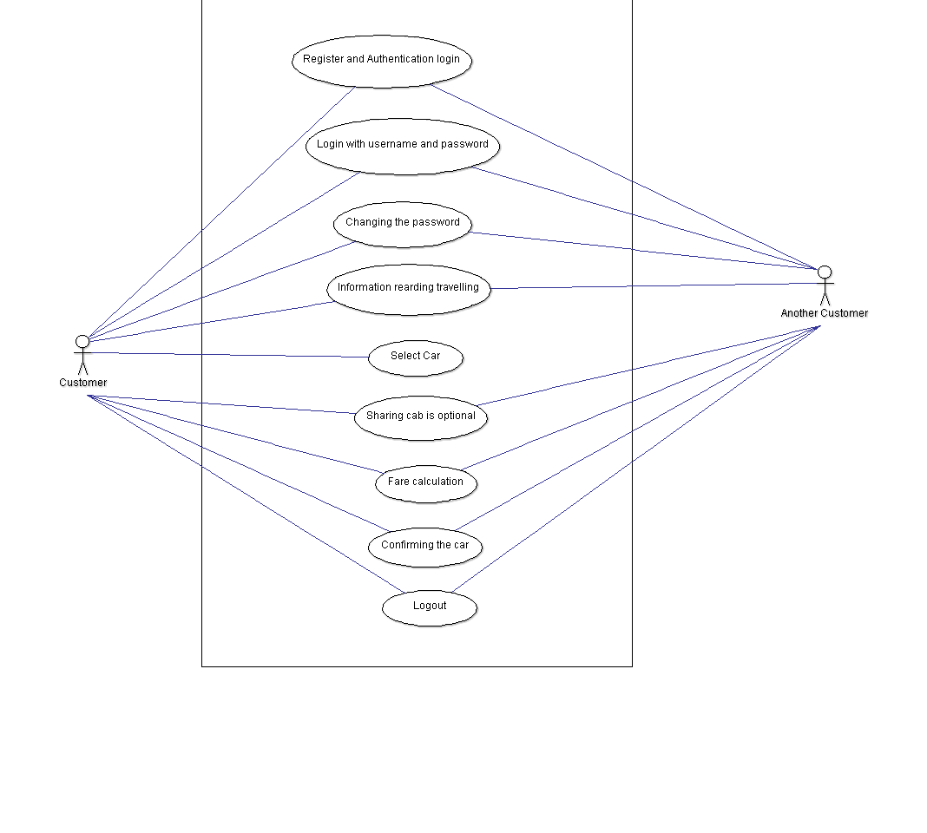
APPENDIX B: ANALYSIS MODEL
This is user side case diagram:

This is employee side:
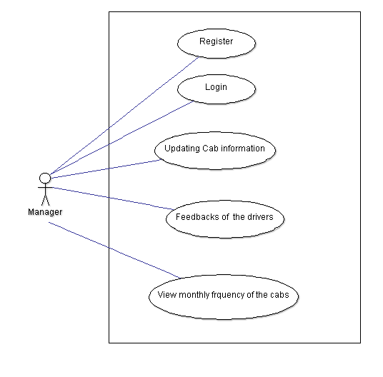

APPENDIX C: TO BE DETERMINED LIST
1.The customer can redirect to other websites in case if they wanted to book for a travel through air,railway,etc..
2.The customer will directly pay to the driver rather than paying only through online on a transaction.

